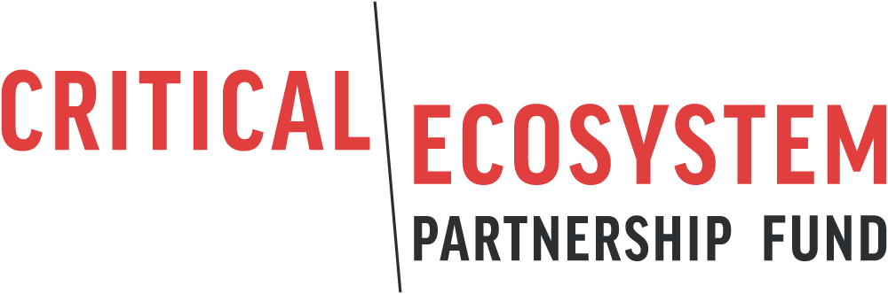

Process Framework for Involuntary Restrictions

Date

CEPF Grant xxxxx

Grantee

Project Title

Project Location

Grant Summary
- Grantee organization.
- Grant title.
- Grant number
- Grant amount (U.S. dollars).
- Proposed dates of grant.
- Countries or territories where project will be undertaken.
- Date of preparation of this document.

The process framework will describe the project and how restrictions of access to natural resources and measures to assist affected communities. Affected communities should have the opportunity to participate in the drafting of the process framework. Typically, the applicant will prepare a draft framework that will then be shared and discussed with local communities and other relevant stakeholders. Based on the consultations, a final framework will be prepared. CEPF may provide guidance on development of the framework and will review and approve the final framework prior to approving the final project proposal application. The process framework should include the following elements:

- Project background

- Participatory implementation

- Criteria for eligibility of affected persons

- Measures to assist the affected persons

- Conflict resolution and complaint mechanism
All projects that trigger a safeguard must provide local communities and other relevant stakeholders with a means to raise a grievance with the grantee, the relevant regional implementation team, the CEPF Secretariat or the World Bank.

This grievance mechanism must include, at a minimum, the following elements.

- Email and telephone contact information for the grantee organization.
- Email and telephone contact information for the CEPF Regional Implementation Team.
- Email and telephone contact information for the local World Bank office.
- The email of the CEPF Executive Director: cepfexecutive@conservation.org.
- A statement describing how you will inform stakeholders of the objectives of the project and the existence of the grievance mechanism (e.g., posters, signboards, public notices, public announcements, use of local languages).
- You should include the following text, exactly, in any grievance mechanism: “We will share all grievances — and a proposed response — with the regional implementation team and the CEPF Grant Director within 15 days. If the claimant is not satisfied following the response, they may submit the grievance directly to the CEPF Executive Director at cepfexecutive@conservation.org or by surface mail. If the claimant is not satisfied with the response from the CEPF Executive Director, they may submit the grievance to the World Bank at the local World Bank office.”

Following the guidance above, describe the grievance mechanism that you will use.

- Implementation arrangements

